Activity Diagram

Develop an activity diagram for one of the use cases that you are prototyping.
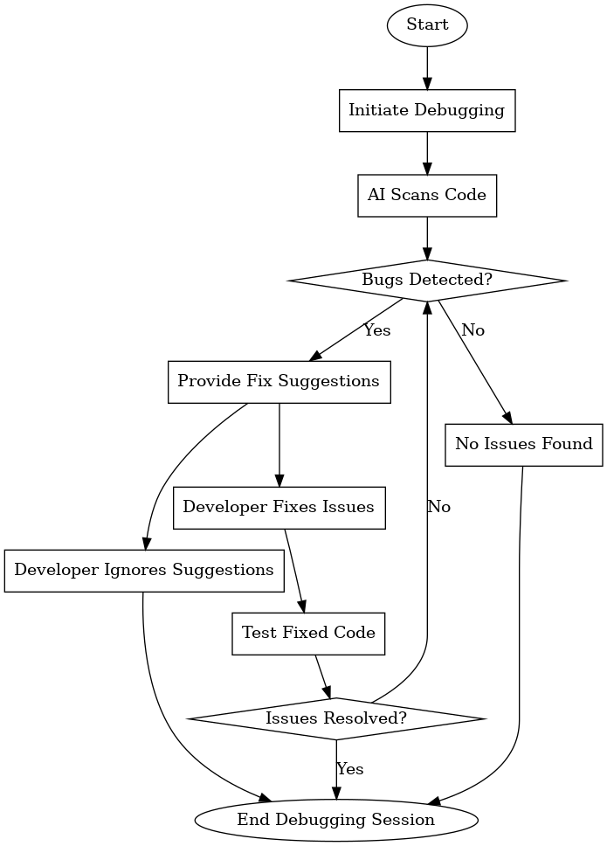
6.1 Diagram Activity Diagram

